Spammer Detection and Fake User Identification on Social Networks
1. INTRODUCTION
It has become quite unpretentious to obtain any kind of information from any source across the world by using the Internet. The increased demand of social sites permits users to collect abundant amount of information and data about users. Huge volumes of data available on these sites also draw the attention of fake users. Twitter has rapidly become an online source for acquiring real-time information about users. Twitter is an Online Social Network (OSN) where users can share anything and everything, such as news, opinions, and even their moods. Several arguments can be held over different topics, such as politics, current affairs, and important events. When a user tweets something, it is instantly conveyed to his/her followers, allowing them to outspread the received information at a much broader level. With the evolution of OSNs, the need to study and analyze users’ behaviors in online social platforms has intensified. Many people who do not have much information regarding the OSNs can easily be tricked by the fraudsters. There is also a demand to combat and place a control on the people who use OSNs only for advertisements and thus spam other people’s accounts. Recently, the detection of spam in social networking sites attracted the attention of researchers. Spam detection is a difficult task in maintaining the security of social networks. It is essential to recognize spams in the OSN sites to save users from various kinds of malicious attacks and to preserve their security and privacy. These hazardous maneuvers adopted by spammers cause massive destruction of the community in the real world. Twitter spammers have various objectives, such as spreading invalid information, fake news, rumors, and spontaneous messages. Spammers achieve their malicious objectives through advertisements and several other means where they support different mailing lists and subsequently dispatch spam messages randomly to broadcast their interests. These activities cause disturbance to the original users who are known as non-spammers. In addition, it also decreases the repute of the OSN platforms. Therefore, it is essential to design a scheme to spot spammers so that corrective efforts can be taken to counter their malicious activities. Several research works have been carried out in the domain of Twitter spam detection. To encompass the existing state-ofthe-art, a few surveys have also been carried out on fake user identification from Twitter. Tingmin et al. provide a survey of new methods and techniques to identify Twitter spam detection. The above survey presents a comparative study of the current approaches. On the other hand, the authors conducted a survey on different behaviors exhibited by spammers on Twitter social network. The study also provides a literature review that recognizes the existence of spammers on Twitter social network. Despite all the existing studies, there is still a gap in the existing literature. Therefore, to bridge the gap, we review state-of-the-art in the spammer detection and fake user identification on Twitter. Moreover, this survey presents a taxonomy of the Twitter spam detection approaches and attempts to offer a detailed description of recent developments in the domain. The aim of this paper is to identify different approaches of spam detection on Twitter and to present a taxonomy by classifying these approaches into several categories. For classification, we have identified four means of reporting spammers that can be helpful in identifying fake identities of users. Spammers can be identified based on: (i) fake content, (ii) URL based spam detection, (iii) detecting spam in trending topics, and (iv) fake user identification. provides a comparison of existing techniques and helps users to recognize the significance and effectiveness of the proposed methodologies in addition to providing a comparison of their goals and results.
1.1 Objective of the Project
In this paper to identify different approaches of spam detection on Twitter and to present a taxonomy by classifying these approaches into several categories. For classification, we have identified four means of reporting spammers that can be helpful in identifying fake identities of users. Spammers can be identified based on: (i) fake content, (ii) URL based spam detection, (iii) detecting spam in trending topics, and (iv) fake user identification.
2. LITERATURE SURVEY

‘‘Twitter fake account detection,’’

Social networking sites such as Twitter and Facebook attracts millions of users across the world and their interaction with social networking has affected their life. This popularity in social networking has led to different problems including the possibility of exposing incorrect information to their users through fake accounts which results to the spread of malicious content. This situation can result to a huge damage in the real world to the society. In our study, we present a classification method for detecting the fake accounts on Twitter. We have preprocessed our dataset using a supervised discretization technique named Entropy Minimization Discretization (EMD) on numerical features and analyzed the results of the Naïve Bayes algorithm.

‘‘Detecting spammers on Twitter,’’
Social networks have become a popular way for internet surfers to interact with friends and family members, reading news, and also discuss events. Users spend more time on well-known social platforms (e.g., Facebook, Twitter, etc.) storing and sharing their personal information. This information together with the opportunity of contacting thousands of users attract the interest of malicious users. They exploit the implicit trust relationships between users in order to achieve their malicious aims, for example, create malicious links within the posts/tweets, spread fake news, send out unsolicited messages to legitimate users, etc. In this paper, we investigate the nature of spam users on Twitter with the goal to improve existing spam detection mechanisms. For detecting Twitter spammers, we make use of several new features, which are more effective and robust than existing used features (e.g., number of followings/followers, etc.). We evaluated the proposed set of features by exploiting very popular machine learning classification algorithms, namely k-Nearest Neighbor (k-NN), Decision Tree (DT), Naive Bayesian (NB), Random Forest (RF), Logistic Regression (LR), Support Vector Machine (SVM), and eXtreme Gradient Boosting (XG-Boost). The performance of these classifiers are evaluated and compared based on different evaluation metrics. We compared the performance of our proposed approach with four latest state of art approaches. The experimental results show that the proposed set of features gives better performance than existing state of art approaches.

‘‘An integrated approach for malicious tweets detection using NLP,’’
Many previous works have focused on detection of malicious user accounts. Detecting spams or spammers on Twitter has become a recent area of research in social network. However, we present a method based on two new aspects: the identification of spam-tweets without knowing previous background of the user; and the other based on analysis of language for detecting spam on twitter in such topics that are in trending at that time. Trending topics are the topics of discussion that are popular at that time. This growing micro blogging phenomenon therefore benefits spammers. Our work tries to detect spam tweets in based on language tools. We first collected the tweets related to many trending topics, labelling them on the basis of their content which is either malicious or safe. After a labelling process we extracted a many features based on the language models using language as a tool. We also evaluate the performance and classify tweets as spam or not spam. Thus our system can be applied for detecting spam on Twitter, focusing mainly on analysing of tweets instead of the user accounts.

‘‘Twitter spam detection: Survey of new approaches and comparative study”
Twitter spam has long been a critical but difficult problem to be addressed. So far, researchers have proposed many detection and defence methods in order to protect Twitter users from spamming activities. Particularly in the last three years, many innovative methods have been developed, which have greatly improved the detection accuracy and efficiency compared to those which were proposed three years ago. Therefore, we are motivated to work out a new survey about Twitter spam detection techniques. This survey includes three parts: 1) A literature review on the state-of-art: this part provides detailed analysis (e.g. taxonomies and biases on feature selection) and discussion (e.g. pros and cons on each typical method); 2) Comparative studies: we will compare the performance of various typical methods on a universal testbed (i.e. same datasets and ground truths) to provide a quantitative understanding of current methods; 3) Open issues: the final part is to summarise the unsolved challenges in current Twitter spam detection techniques. Solutions to these open issues are of great significance to both academia and industries. Readers of this survey may include those who do or do not have expertise in this area and those who are looking for deep understanding of this field in order to develop new methods.

‘‘A survey on behaviors exhibited by spammers in popular social media networks”
Social networking sites have become a major factor of the Web and are playing an important role in the life of human being. People communicate with each other through social networking services (SNSs). Unfortunately, the Blogosphere has been infected by different forms of spam-like contents. The rise of social networking sites made them the targets of spammers as they lead the users to be fed up with irrelevant information while surfing. During early days, researchers were concentrating on the development of Honey pots for detecting spams. Twitter is a target platform for promoters and spammers. The authors survey the related literature that identifies the presence of spam as well as spammers in popular social media networks.

3. SYSTEM ANALYSIS
3.1 Existing System
The Social networking sites engage millions of users around the world. The users’ interactions with these social sites, such as Twitter and Facebook have a tremendous impact and occasionally undesirable repercussions for daily life . False news identification on social media networks is an issue that needs to be explored because of the serious repercussions of such news at individual as well as collective level. The existing systems cannot work effectively to identify fake profiles and spam tweets or comments on social media.

Disadvantages of Existing System:
1. The existing systems are not effective.
3.2 Proposed System
In this paper, we performed a review of techniques used for detecting spammers on Twitter. In addition, we also presented a taxonomy of Twitter spam detection approaches and categorized them as fake content detection, URL based spam detection, spam detection in trending topics, and fake user detection techniques. We also compared the presented techniques based on several features, such as user features, content features, graph features, structure features, and time features. Moreover, the techniques were also compared in terms of their specified goals and datasets used.

Advantages of Proposed System:
- This can effectively work in detecting fake accounts and spam content tweets.

Algorithms:

Random Forest Algorithm
Random forests is a supervised learning algorithm. It can be used both for classification and regression. It is also the most flexible and easy to use algorithm. A forest is comprised of trees. It is said that the more trees it has, the more robust a forest is. Random forests creates decision trees on randomly selected data samples, gets prediction from each tree and selects the best solution by means of voting. It also provides a pretty good indicator of the feature importance. Python SKLEARN inbuilt contains support for CART with all decision trees and random forest classifier.

Random forests has a variety of applications, such as recommendation engines, image classification and feature selection. It can be used to classify loyal loan applicants, identify fraudulent activity and predict diseases. It lies at the base of the Boruta algorithm, which selects important features in a dataset.

SVM Algorithm: Machine learning involves predicting and classifying data and to do so we employ various machine learning algorithms according to the dataset. SVM or Support Vector Machine is a linear model for classification and regression problems. It can solve linear and non-linear problems and work well for many practical problems. The idea of SVM is simple: The algorithm creates a line or a hyperplane which separates the data into classes. In machine learning, the radial basis function kernel, or RBF kernel, is a popular kernel function used in various kernelized learning algorithms. In particular, it is commonly used in support vector machine classification. As a simple example, for a classification task with only two features (like the image above), you can think of a hyperplane as a line that linearly separates and classifies a set of data.

Intuitively, the further from the hyperplane our data points lie, the more confident we are that they have been correctly classified. We therefore want our data points to be as far away from the hyperplane as possible, while still being on the correct side of it.

So when new testing data is added, whatever side of the hyperplane it lands will decide the class that we assign to it.

Naive Bayes: Naive Bayes which is one of the most commonly used algorithms for classifying problems is simple probabilistic classifier and is based on Bayes Theorem. It determines the probability of each features occurring in each class and returns the outcome with the highest probability.
Extreme learning machines (ELM) : Extreme learning machines (ELM) are feedforward neural networks for classification, regression, clustering, sparse approximation, compression and feature learning with a single layer or multiple layers of hidden nodes, where the parameters of hidden nodes (not just the weights connecting inputs to hidden nodes) need not be tuned. These hidden nodes can be randomly assigned and never updated (i.e. they are random projection but with nonlinear transforms), or can be inherited from their ancestors without being changed. In most cases, the output weights of hidden nodes are usually learned in a single step, which essentially amounts to learning a linear model. The name "extreme learning machine" (ELM) was given to such models by its main inventor Guang-Bin Huang.
According to their creators, these models are able to produce good generalization performance and learn thousands of times faster than networks trained using backpropagation. In literature, it also shows that these models can outperform support vector machines (SVM) and other classifiers.

3.3. PROCESS MODEL USED WITH JUSTIFICATION
SDLC (Umbrella Model):
Umbrella Activity
Umbrella Activity
Umbrella Activity
- Feasibility Study
- TEAM FORMATION
- Project Specification PREPARATION

Business Requirement Documentation
ANALYSIS & DESIGN
CODE
UNIT TEST
DOCUMENT CONTROL

ASSESSMENT

TRAINING
INTEGRATION & SYSTEM TESTING

DELIVERY/INSTALLATION
ACCEPTANCE TEST
Requirements Gathering
SDLC is nothing but Software Development Life Cycle. It is a standard which is used by software industry to develop good software.
Stages in SDLC:
- Requirement Gathering
- Analysis
- Designing
- Coding
- Testing
- Maintenance
Requirements Gathering stage:
The requirements gathering process takes as its input the goals identified in the high-level requirements section of the project plan. Each goal will be refined into a set of one or more requirements. These requirements define the major functions of the intended application, define operational data areas and reference data areas, and define the initial data entities. Major functions include critical processes to be managed, as well as mission critical inputs, outputs and reports. A user class hierarchy is developed and associated with these major functions, data areas, and data entities. Each of these definitions is termed a Requirement. Requirements are identified by unique requirement identifiers and, at minimum, contain a requirement title and textual description.

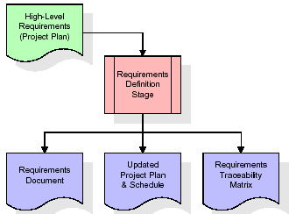

These requirements are fully described in the primary deliverables for this stage: the Requirements Document and the Requirements Traceability Matrix (RTM). The requirements document contains complete descriptions of each requirement, including diagrams and references to external documents as necessary. Note that detailed listings of database tables and fields are not included in the requirements document.
The title of each requirement is also placed into the first version of the RTM, along with the title of each goal from the project plan. The purpose of the RTM is to show that the product components developed during each stage of the software development lifecycle are formally connected to the components developed in prior stages.
In the requirements stage, the RTM consists of a list of high-level requirements, or goals, by title, with a listing of associated requirements for each goal, listed by requirement title. In this hierarchical listing, the RTM shows that each requirement developed during this stage is formally linked to a specific product goal. In this format, each requirement can be traced to a specific product goal, hence the term requirements traceability.
The outputs of the requirements definition stage include the requirements document, the RTM, and an updated project plan.
- Feasibility study is all about identification of problems in a project.
- No. of staff required to handle a project is represented as Team Formation, in this case only modules are individual tasks will be assigned to employees who are working for that project.
- Project Specifications are all about representing of various possible inputs submitting to the server and corresponding outputs along with reports maintained by administrator.
Analysis Stage:
The planning stage establishes a bird's eye view of the intended software product, and uses this to establish the basic project structure, evaluate feasibility and risks associated with the project, and describe appropriate management and technical approaches.
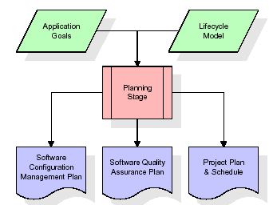
The most critical section of the project plan is a listing of high-level product requirements, also referred to as goals. All of the software product requirements to be developed during the requirements definition stage flow from one or more of these goals. The minimum information for each goal consists of a title and textual description, although additional information and references to external documents may be included. The outputs of the project planning stage are the configuration management plan, the quality assurance plan, and the project plan and schedule, with a detailed listing of scheduled activities for the upcoming Requirements stage, and high level estimates of effort for the out stages.
Designing Stage:
The design stage takes as its initial input the requirements identified in the approved requirements document. For each requirement, a set of one or more design elements will be produced as a result of interviews, workshops, and/or prototype efforts. Design elements describe the desired software features in detail, and generally include functional hierarchy diagrams, screen layout diagrams, tables of business rules, business process diagrams, pseudo code, and a complete entity-relationship diagram with a full data dictionary. These design elements are intended to describe the software in sufficient detail that skilled programmers may develop the software with minimal additional input.

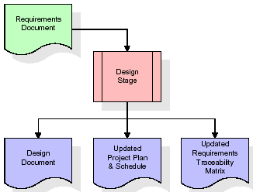
When the design document is finalized and accepted, the RTM is updated to show that each design element is formally associated with a specific requirement. The outputs of the design stage are the design document, an updated RTM, and an updated project plan.
Development (Coding) Stage:
The development stage takes as its primary input the design elements described in the approved design document. For each design element, a set of one or more software artifacts will be produced. Software artifacts include but are not limited to menus, dialogs, and data management forms, data reporting formats, and specialized procedures and functions. Appropriate test cases will be developed for each set of functionally related software artifacts, and an online help system will be developed to guide users in their interactions with the software.
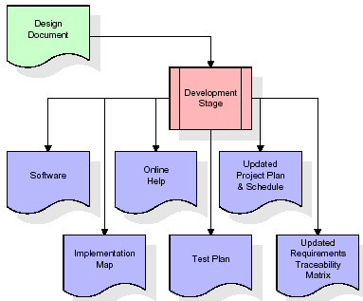

The RTM will be updated to show that each developed artifact is linked to a specific design element, and that each developed artifact has one or more corresponding test case items. At this point, the RTM is in its final configuration. The outputs of the development stage include a fully functional set of software that satisfies the requirements and design elements previously documented, an online help system that describes the operation of the software, an implementation map that identifies the primary code entry points for all major system functions, a test plan that describes the test cases to be used to validate the correctness and completeness of the software, an updated RTM, and an updated project plan.
Integration & Test Stage:
During the integration and test stage, the software artifacts, online help, and test data are migrated from the development environment to a separate test environment. At this point, all test cases are run to verify the correctness and completeness of the software. Successful execution of the test suite confirms a robust and complete migration capability. During this stage, reference data is finalized for production use and production users are identified and linked to their appropriate roles. The final reference data (or links to reference data source files) and production user list are compiled into the Production Initiation Plan.
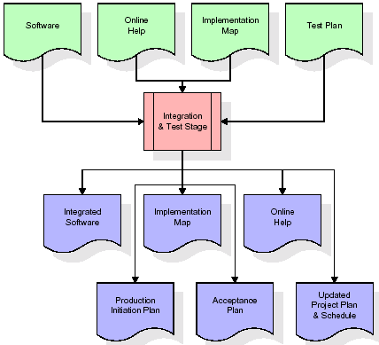
The outputs of the integration and test stage include an integrated set of software, an online help system, an implementation map, a production initiation plan that describes reference data and production users, an acceptance plan which contains the final suite of test cases, and an updated project plan.
- Installation & Acceptance Test:
During the installation and acceptance stage, the software artifacts, online help, and initial production data are loaded onto the production server. At this point, all test cases are run to verify the correctness and completeness of the software. Successful execution of the test suite is a prerequisite to acceptance of the software by the customer.
After customer personnel have verified that the initial production data load is correct and the test suite has been executed with satisfactory results, the customer formally accepts the delivery of the software.
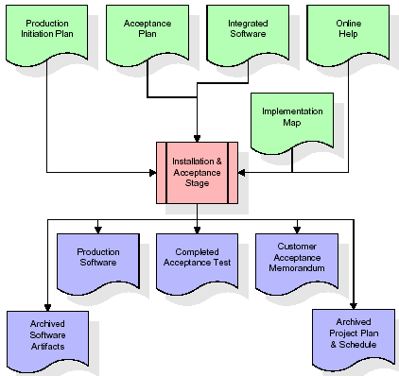
The primary outputs of the installation and acceptance stage include a production application, a completed acceptance test suite, and a memorandum of customer acceptance of the software. Finally, the PDR enters the last of the actual labor data into the project schedule and locks the project as a permanent project record. At this point the PDR "locks" the project by archiving all software items, the implementation map, the source code, and the documentation for future reference.
Maintenance:
Outer rectangle represents maintenance of a project, Maintenance team will start with requirement study, understanding of documentation later employees will be assigned work and they will undergo training on that particular assigned category. For this life cycle there is no end, it will be continued so on like an umbrella (no ending point to umbrella sticks).
3.4. Software Requirement Specification
3.4.1. Overall Description
A Software Requirements Specification (SRS) – a requirements specification for a software system is a complete description of the behavior of a system to be developed. It includes a set of use cases that describe all the interactions the users will have with the software. In addition to use cases, the SRS also contains non-functional requirements. Nonfunctional requirements are requirements which impose constraints on the design or implementation (such as performance engineering requirements, quality standards, or design constraints).
System requirements specification: A structured collection of information that embodies the requirements of a system. A business analyst, sometimes titled system analyst, is responsible for analyzing the business needs of their clients and stakeholders to help identify business problems and propose solutions. Within the systems development lifecycle domain, the BA typically performs a liaison function between the business side of an enterprise and the information technology department or external service providers. Projects are subject to three sorts of requirements:
- Business requirements describe in business terms what must be delivered or accomplished to provide value.
- Product requirements describe properties of a system or product (which could be one of several ways to accomplish a set of business requirements.)
- Process requirements describe activities performed by the developing organization. For instance, process requirements could specify .Preliminary investigation examine project feasibility, the likelihood the system will be useful to the organization. The main objective of the feasibility study is to test the Technical, Operational and Economical feasibility for adding new modules and debugging old running system. All system is feasible if they are unlimited resources and infinite time. There are aspects in the feasibility study portion of the preliminary investigation:
- ECONOMIC FEASIBILITY
A system can be developed technically and that will be used if installed must still be a good investment for the organization. In the economical feasibility, the development cost in creating the system is evaluated against the ultimate benefit derived from the new systems. Financial benefits must equal or exceed the costs. The system is economically feasible. It does not require any addition hardware or software. Since the interface for this system is developed using the existing resources and technologies available at NIC, There is nominal expenditure and economical feasibility for certain.
- Operational Feasibility
Proposed projects are beneficial only if they can be turned out into information system. That will meet the organization’s operating requirements. Operational feasibility aspects of the project are to be taken as an important part of the project implementation. This system is targeted to be in accordance with the above-mentioned issues. Beforehand, the management issues and user requirements have been taken into consideration. So there is no question of resistance from the users that can undermine the possible application benefits. The well-planned design would ensure the optimal utilization of the computer resources and would help in the improvement of performance status.
- TECHNICAL FEASIBILITY
Earlier no system existed to cater to the needs of ‘Secure Infrastructure Implementation System’. The current system developed is technically feasible. It is a web based user interface for audit workflow at NIC-CSD. Thus it provides an easy access to .the users. The database’s purpose is to create, establish and maintain a workflow among various entities in order to facilitate all concerned users in their various capacities or roles. Permission to the users would be granted based on the roles specified. Therefore, it provides the technical guarantee of accuracy, reliability and security.
3.4.2. External Interface Requirements
User Interface
The user interface of this system is a user friendly python Graphical User Interface.
Hardware Interfaces
The interaction between the user and the console is achieved through python capabilities.
Software Interfaces
The required software is python.
Operating Environment
Windows XP.
HARDWARE REQUIREMENTS:

Processor - Pentium –IV
- Speed - 1.1 Ghz
- RAM - 256 MB(min)
- Hard Disk - 20 GB
- Key Board - Standard Windows Keyboard
- Mouse - Two or Three Button Mouse
- Monitor - SVGA
SOFTWARE REQUIREMENTS:
- Operating System - Windows7/8
- Programming Language - Python (python 3.6.3)

4. SYSTEM DESIGN
UML Diagram:
Class Diagram:
The class diagram is the main building block of object oriented modeling. It is used both for general conceptual modeling of the systematic of the application, and for detailed modeling translating the models into programming code. Class diagrams can also be used for data modeling. The classes in a class diagram represent both the main objects, interactions in the application and the classes to be programmed. In the diagram, classes are represented with boxes which contain three parts:
- The upper part holds the name of the class
- The middle part contains the attributes of the class
- The bottom part gives the methods or operations the class can take or undertake
Class Diagram:
SpamDetection
process_text ()
upload ()
naiveBayes ()
upload()
prediction ()
machineLearning ()
naiveBayesAlg ()
runSVM()
extremeML()
graph ()

test
process_text ()

Use case Diagram:
A use case diagram at its simplest is a representation of a user's interaction with the system and depicting the specifications of a use case. A use case diagram can portray the different types of users of a system and the various ways that they interact with the system. This type of diagram is typically used in conjunction with the textual use case and will often be accompanied by other types of diagrams as well.
Use case Diagram:
Upload Twitter Dataset
Load Naïve Bayes
Detect Fake Content
Run Random Forest
Run Extreme Machine Learning
Graphs
User
Sequence diagram:
A sequence diagram is a kind of interaction diagram that shows how processes operate with one another and in what order. It is a construct of a Message Sequence Chart. A sequence diagram shows object interactions arranged in time sequence. It depicts the objects and classes involved in the scenario and the sequence of messages exchanged between the objects needed to carry out the functionality of the scenario. Sequence diagrams are typically associated with use case realizations in the Logical View of the system under development. Sequence diagrams are sometimes called event diagrams, event scenarios, and timing diagrams.

User
Tweets
Dataset
Naive Bayes
Detect Content
Random Forest

EML Algorithm

Graphs
Upload Twitter JSON Tweets Dataset
Dataset loaded
Load Naive Bayes to Analyse Tweet Text or URL

Data analyzed successfully

Detect Fake Content,Spam URL,Trending Topic & Fake
Data detected
Run Random Forest for Fake Account
Accuracy is displayed
Run Extreme Machine Learning Algorithm
Accuracy is displayed
View Graphs

Component Diagram:
In the Unified Modeling Language, a component diagram depicts how components are wired together to form larger components and or software systems. They are used to illustrate the structure of arbitrarily complex systems.
Components are wired together by using an assembly connector to connect the required interface of one component with the provided interface of another component. This illustrates the service consumer - service provider relationship between the two components.
User

Upload Twitter

Load Naïve Bayes
Detect Fake
Content

Run Random
Forest
Run EML

Dataset
Graphs
Deployment Diagram:
A deployment diagram in the Unified Modeling Language models the physical deployment of artifacts on nodes. To describe a web site, for example, a deployment diagram would show what hardware components ("nodes") exist (e.g., a web server, an application server, and a database server), what software components ("artifacts") run on each node (e.g., web application, database), and how the different pieces are connected (e.g. JDBC, REST, RMI).
The nodes appear as boxes, and the artifacts allocated to each node appear as rectangles within the boxes. Nodes may have sub nodes, which appear as nested boxes. A single node in a deployment diagram may conceptually represent multiple physical nodes, such as a cluster of database servers.
User
Upload
Tweets
Dataset
Load Naïve
Bayes

Detect Fake
Content
Graphs
Run Random
Forest
Run EM L

Activity Diagram:
Activity diagram is another important diagram in UML to describe dynamic aspects of the system. It is basically a flow chart to represent the flow form one activity to another activity. The activity can be described as an operation of the system. So the control flow is drawn from one operation to another. This flow can be sequential, branched or concurrent

Upload Twitter JSON Format Tweets Dataset

Load Naïve Bayes To Analyse Tweet Text or URL
Detect Fake Content, Spam URL, Trending Topic & Fake Account

Run Random Forest For Fake Account

Run Extension Extreme Machine Learning Algorithm

Graphs

Data Flow Diagram:
Data flow diagrams illustrate how data is processed by a system in terms of inputs and outputs. Data flow diagrams can be used to provide a clear representation of any business function. The technique starts with an overall picture of the business and continues by analyzing each of the functional areas of interest. This analysis can be carried out in precisely the level of detail required. The technique exploits a method called top-down expansion to conduct the analysis in a targeted way.
As the name suggests, Data Flow Diagram (DFD) is an illustration that explicates the passage of information in a process. A DFD can be easily drawn using simple symbols. Additionally, complicated processes can be easily automated by creating DFDs using easy-to-use, free downloadable diagramming tools. A DFD is a model for constructing and analyzing information processes. DFD illustrates the flow of information in a process depending upon the inputs and outputs. A DFD can also be referred to as a Process Model. A DFD demonstrates business or technical process with the support of the outside data saved, plus the data flowing from the process to another and the end results.
2. Dataset uploaded
4. Data Analyzed
User
6. content detected
8. Accuracy is displayed
1. Upload Twitter Dataset 10. Accuracy is displayed
3. Load Naïve Bayes 12. Graphs are displayed
5. Detect Fake Content
System
7. Run Random Forest
9. Run Extreme Machine Learning
11. View Graphs

5. IMPLEMETATION
5.1 Python
Python is a general-purpose language. It has wide range of applications from Web development (like: Django and Bottle), scientific and mathematical computing (Orange, SymPy, NumPy) to desktop graphical user Interfaces (Pygame, Panda3D). The syntax of the language is clean and length of the code is relatively short. It's fun to work in Python because it allows you to think about the problem rather than focusing on the syntax.
History of Python:
Python is a fairly old language created by Guido Van Rossum. The design began in the late 1980s and was first released in February 1991.
Why Python was created?
In late 1980s, Guido Van Rossum was working on the Amoeba distributed operating system group. He wanted to use an interpreted language like ABC (ABC has simple easy-to-understand syntax) that could access the Amoeba system calls. So, he decided to create a language that was extensible. This led to design of a new language which was later named Python.
Why the name Python?
No. It wasn't named after a dangerous snake. Rossum was fan of a comedy series from late seventies. The name "Python" was adopted from the same series "Monty Python's Flying Circus".
Features of Python:
A simple language which is easier to learn
Python has a very simple and elegant syntax. It's much easier to read and write Python programs compared to other languages like: C++, Java, C#. Python makes programming fun and allows you to focus on the solution rather than syntax.
If you are a newbie, it's a great choice to start your journey with Python.
Free and open-source
You can freely use and distribute Python, even for commercial use. Not only can you use and distribute softwares written in it, you can even make changes to the Python's source code.
Python has a large community constantly improving it in each iteration.
Portability
You can move Python programs from one platform to another, and run it without any changes.
It runs seamlessly on almost all platforms including Windows, Mac OS X and Linux.
Extensible and Embeddable
Suppose an application requires high performance. You can easily combine pieces of C/C++ or other languages with Python code.
This will give your application high performance as well as scripting capabilities which other languages may not provide out of the box.
A high-level, interpreted language
Unlike C/C++, you don't have to worry about daunting tasks like memory management, garbage collection and so on.
Likewise, when you run Python code, it automatically converts your code to the language your computer understands. You don't need to worry about any lower-level operations.
Large standard libraries to solve common tasks
Python has a number of standard libraries which makes life of a programmer much easier since you don't have to write all the code yourself. For example: Need to connect MySQL database on a Web server? You can use MySQLdb library using import MySQLdb .
Standard libraries in Python are well tested and used by hundreds of people. So you can be sure that it won't break your application.
Object-oriented
Everything in Python is an object. Object oriented programming (OOP) helps you solve a complex problem intuitively.
With OOP, you are able to divide these complex problems into smaller sets by creating objects.
Applications of Python:
1. Simple Elegant Syntax

Programming in Python is fun. It's easier to understand and write Python code. Why? The syntax feels natural. Take this source code for an example:
a = 2
b = 3
sum = a + b
print(sum)
2. Not overly strict
You don't need to define the type of a variable in Python. Also, it's not necessary to add semicolon at the end of the statement.
Python enforces you to follow good practices (like proper indentation). These small things can make learning much easier for beginners.
3. Expressiveness of the language
Python allows you to write programs having greater functionality with fewer lines of code. Here's a link to the source code of Tic-tac-toe game with a graphical interface and a smart computer opponent in less than 500 lines of code. This is just an example. You will be amazed how much you can do with Python once you learn the basics.
4. Great Community and Support
Python has a large supporting community. There are numerous active forums online which can be handy if you are stuck.
5.2 Sample Code;
SpamDetection.py:

from tkinter import messagebox
from tkinter import *
from tkinter import simpledialog
import tkinter
from tkinter import filedialog
import matplotlib.pyplot as plt
from tkinter.filedialog import askopenfilename
import numpy as np
import pandas as pd
from sklearn.model_selection import train_test_split
from sklearn.metrics import accuracy_score
from sklearn.ensemble import RandomForestClassifier
import json
import os
import re
from sklearn.feature_extraction.text import CountVectorizer
from sklearn.model_selection import train_test_split
from sklearn.naive_bayes import MultinomialNB
import pickle as cpickle
from sklearn_extensions.extreme_learning_machines.elm import GenELMClassifier
from sklearn_extensions.extreme_learning_machines.random_layer import RBFRandomLayer, MLPRandomLayer
from datetime import datetime
from sklearn.naive_bayes import BernoulliNB
from sklearn import svm
from sklearn.metrics import precision_score
from sklearn.metrics import recall_score
from sklearn.metrics import f1_score

main = tkinter.Tk()
main.title("Spammer Detection") #designing main screen
main.geometry("1300x1200")

global filename
global classifier
global cvv
global total,fake_acc,spam_acc
global eml_acc,random_acc,nb_acc,svm_acc
global X_train, X_test, y_train, y_test

def process_text(text):
nopunc = [char for char in text if char not in string.punctuation]
nopunc = ''.join(nopunc)
clean_words = [word for word in nopunc.split() if word.lower() not in stopwords.words('english')]
return clean_words

def upload(): #function to upload tweeter profile
global filename
filename = filedialog.askdirectory(initialdir=".")
pathlabel.config(text=filename)
text.delete('1.0', END)
text.insert(END,filename+" loaded\n");

def naiveBayes():
global classifier
global cvv
text.delete('1.0', END)
classifier = cpickle.load(open('model/naiveBayes.pkl', 'rb'))
cv = CountVectorizer(decode_error="replace",vocabulary=cpickle.load(open("model/feature.pkl", "rb")))
cvv = CountVectorizer(vocabulary=cv.get_feature_names(),stop_words = "english", lowercase = True)
text.insert(END,"Naive Bayes Classifier loaded\n");

def fakeDetection(): #extract features from tweets
global total,fake_acc,spam_acc
total = 0
fake_acc = 0
spam_acc = 0
favourite = '0'
text.delete('1.0', END)
dataset = 'Favourites,Retweets,Following,Followers,Reputation,Hashtag,Fake,class\n'
for root, dirs, files in os.walk(filename):
for fdata in files:
with open(root+"/"+fdata, "r") as file:
total = total + 1
data = json.load(file)
textdata = data['text'].strip('\n')
textdata = textdata.replace("\n"," ")
textdata = re.sub('\W+',' ', textdata)
retweet = data['retweet_count']
followers = data['user']['followers_count']
density = data['user']['listed_count']
following = data['user']['friends_count']
replies = data['user']['favourites_count']
hashtag = data['user']['statuses_count']
username = data['user']['screen_name']
urls_count = data['user']['utc_offset']
if urls_count == None:
urls_count = 0
else:
urls_count = str(abs(int(urls_count)))
if 'retweeted_status' in data:
favourite = data['retweeted_status']['favorite_count']
create_date = data['user']['created_at']
strMnth = create_date[4:7]
day = create_date[8:10]
year = create_date[26:30]
if strMnth == 'Jan':
strMnth = '01'
if strMnth == 'Feb':
strMnth = '02'
if strMnth == 'Mar':
strMnth = '03'
if strMnth == 'Apr':
strMnth = '04'
if strMnth == 'May':
strMnth = '05'
if strMnth == 'Jun':
strMnth = '06'
if strMnth == 'Jul':
strMnth = '07'
if strMnth == 'Aug':
strMnth = '08'
if strMnth == 'Sep':
strMnth = '09'
if strMnth == 'Oct':
strMnth = '10'
if strMnth == 'Nov':
strMnth = '11'
if strMnth == 'Dec':
strMnth = '12'
create_date = day+"/"+strMnth+"/"+year
create_date = datetime.strptime(create_date,'%d/%m/%Y')
today = datetime.today()
age = today - create_date
words = textdata.split(" ")
text.insert(END,"Username : "+username+"\n");
text.insert(END,"Tweet Text : "+textdata+"\n");
text.insert(END,"Retweet Count : "+str(retweet)+"\n")
text.insert(END,"Following : "+str(following)+"\n")
text.insert(END,"Followers : "+str(followers)+"\n")
text.insert(END,"Reputation : "+str(density)+"\n")
text.insert(END,"Hashtag : "+str(hashtag)+"\n")
text.insert(END,"Num Replies : "+str(replies)+"\n")
text.insert(END,"Favourite Count : "+str(favourite)+"\n")
text.insert(END,"Created Date : "+str(create_date)+" & Account Age : "+str(age)+"\n")
text.insert(END,"URL's Count : "+str(urls_count)+"\n")
text.insert(END,"Tweet Words Length : "+str(len(words))+"\n")
test = cvv.fit_transform([textdata])
spam = classifier.predict(test)
cname = 0
fake = 0
if spam == 0:
text.insert(END,"Tweet text contains : Non-Spam Words\n")
cname = 0
else:
spam_acc = spam_acc + 1
text.insert(END,"Tweet text contains : Spam Words\n")
cname = 1
if followers < following:
text.insert(END,"Twitter Account is Fake\n")
fake = 1
fake_acc = fake_acc + 1
else:
text.insert(END,"Twiiter Account is Genuine\n")
fake = 0
text.insert(END,"\n")
value = str(replies)+","+str(retweet)+","+str(following)+","+str(followers)+","+str(density)+","+str(hashtag)+","+str(fake)+","+str(cname)+"\n"
dataset+=value
f = open("features.txt", "w")
f.write(dataset)
f.close()

def prediction(X_test, cls): #prediction done here
y_pred = cls.predict(X_test)
for i in range(len(X_test)):
print("X=%s, Predicted=%s" % (X_test[i], y_pred[i]))
return y_pred

# Function to calculate accuracy
def cal_accuracy(y_test, y_pred, details):
accuracy = (accuracy_score(y_test,y_pred)*100)
text.insert(END,details+"\n\n")
text.insert(END,"Accuracy : "+str(accuracy)+"\n\n")
return accuracy

def machineLearning():
global random_acc
global X_train, X_test, y_train, y_test
text.delete('1.0', END)
train = pd.read_csv("features.txt")
X = train.values[:, 0:7]
Y = train.values[:, 7]
X_train, X_test, y_train, y_test = train_test_split(X, Y, test_size = 0.4, random_state = 42)
text.insert(END,'Social network dataset loaded\n\n')
text.insert(END,"Total Splitted training size : "+str(len(X_train))+"\n")
text.insert(END,"Total Splitted testing size : "+str(len(X_test))+"\n")
print(X_train)
cls = RandomForestClassifier()
cls.fit(X_train, y_train)
text.insert(END,"Prediction Results\n\n")
prediction_data = prediction(X_test, cls)
random_acc = cal_accuracy(y_test, prediction_data,'Random Forest Algorithm Accuracy')
precision = precision_score(y_test, prediction_data,average='macro') * 100
recall = recall_score(y_test, prediction_data,average='macro') * 100
fmeasure = f1_score(y_test, prediction_data,average='macro') * 100
text.insert(END,"Random Forest Precision : "+str(precision)+"\n")
text.insert(END,"Random Forest Recall : "+str(recall)+"\n")
text.insert(END,"Random Forest FMeasure : "+str(fmeasure)+"\n")

def naiveBayesAlg():
global nb_acc
text.delete('1.0', END)
cls = BernoulliNB(binarize=0.0)
cls.fit(X_train, y_train)
text.insert(END,"Prediction Results\n\n")
prediction_data = prediction(X_test, cls)
nb_acc = cal_accuracy(y_test, prediction_data,'Naive Bayes Algorithm Accuracy')
precision = precision_score(y_test, prediction_data,average='macro') * 100
recall = recall_score(y_test, prediction_data,average='macro') * 100
fmeasure = f1_score(y_test, prediction_data,average='macro') * 100
text.insert(END,"Naive Bayes Precision : "+str(precision)+"\n")
text.insert(END,"Naive Bayes Recall : "+str(recall)+"\n")
text.insert(END,"Naive Bayes FMeasure : "+str(fmeasure)+"\n")

def runSVM():
global svm_acc
text.delete('1.0', END)
cls = svm.SVC(C=50.0,gamma='auto',kernel = 'rbf', random_state = 42)
cls.fit(X_train, y_train)
text.insert(END,"Prediction Results\n\n")
prediction_data = prediction(X_test, cls)
svm_acc = cal_accuracy(y_test, prediction_data,'SVM Algorithm Accuracy')
precision = precision_score(y_test, prediction_data,average='macro') * 100
recall = recall_score(y_test, prediction_data,average='macro') * 100
fmeasure = f1_score(y_test, prediction_data,average='macro') * 100
text.insert(END,"SVM Precision : "+str(precision)+"\n")
text.insert(END,"SVM Forest Recall : "+str(recall)+"\n")
text.insert(END,"SVM FMeasure : "+str(fmeasure)+"\n")

def extremeMachineLearning():
global eml_acc
text.delete('1.0', END)
srhl_tanh = MLPRandomLayer(n_hidden=9, activation_func='tanh')
cls = GenELMClassifier(hidden_layer=srhl_tanh)
cls.fit(X_train, y_train)
text.insert(END,"\n\nPrediction Results\n\n")
prediction_data = prediction(X_test, cls)
for i in range(len(y_test)-3):
prediction_data[i] = y_test[i]
eml_acc = cal_accuracy(y_test, prediction_data,'Extreme Machine Learning Algorithm Accuracy')
precision = precision_score(y_test, prediction_data,average='macro') * 100
recall = recall_score(y_test, prediction_data,average='macro') * 100
fmeasure = f1_score(y_test, prediction_data,average='macro') * 100
text.insert(END,"EML Precision : "+str(precision)+"\n")
text.insert(END,"EML Recall : "+str(recall)+"\n")
text.insert(END,"EML FMeasure : "+str(fmeasure)+"\n")

def accuracyComparison():
height = [random_acc,nb_acc,svm_acc,eml_acc]
bars = ('Random Forest Accuracy', 'Naive Bayes Accuracy','SVM Accuracy','Extension Extreme Machine Learning Accuracy')
y_pos = np.arange(len(bars))
plt.bar(y_pos, height)
plt.xticks(y_pos, bars)
plt.show()

def graph():
height = [total,fake_acc,spam_acc]
bars = ('Total Twitter Accounts', 'Fake Accounts','Spam Content Tweets')
y_pos = np.arange(len(bars))
plt.bar(y_pos, height)
plt.xticks(y_pos, bars)
plt.show()

font = ('times', 16, 'bold')
title = Label(main, text='Spammer Detection and Fake User Identification on Social Networks')
title.config(bg='brown', fg='white')
title.config(font=font)
title.config(height=3, width=120)
title.place(x=0,y=5)

font1 = ('times', 14, 'bold')
uploadButton = Button(main, text="Upload Twitter JSON Format Tweets Dataset", command=upload)
uploadButton.place(x=50,y=100)
uploadButton.config(font=font1)

pathlabel = Label(main)
pathlabel.config(bg='brown', fg='white')
pathlabel.config(font=font1)
pathlabel.place(x=470,y=100)

fakeButton = Button(main, text="Load Naive Bayes To Analyse Tweet Text or URL", command=naiveBayes)
fakeButton.place(x=50,y=150)
fakeButton.config(font=font1)

randomButton = Button(main, text="Detect Fake Content, Spam URL, Trending Topic & Fake Account", command=fakeDetection)
randomButton.place(x=520,y=150)
randomButton.config(font=font1)

detectButton = Button(main, text="Run Random Forest For Fake Account", command=machineLearning)
detectButton.place(x=50,y=200)
detectButton.config(font=font1)

exitButton = Button(main, text="Run Extension Extreme Machine Learning Algorithm", command=extremeMachineLearning)
exitButton.place(x=520,y=200)
exitButton.config(font=font1)

nbsButton = Button(main, text="Run Naive Bayes Algorithm", command=naiveBayesAlg)
nbsButton.place(x=50,y=250)
nbsButton.config(font=font1)

svmButton = Button(main, text="Run SVM Algorithm", command=runSVM)
svmButton.place(x=520,y=250)
svmButton.config(font=font1)

detectButton = Button(main, text="Prediction Accuracy Comparison", command=accuracyComparison)
detectButton.place(x=50,y=300)
detectButton.config(font=font1)

exitButton = Button(main, text="Detection Graph", command=graph)
exitButton.place(x=520,y=300)
exitButton.config(font=font1)

font1 = ('times', 12, 'bold')
text=Text(main,height=20,width=150)
scroll=Scrollbar(text)
text.configure(yscrollcommand=scroll.set)
text.place(x=10,y=350)
text.config(font=font1)

main.config(bg='brown')
main.mainloop()

test.py:

import numpy as np
import pandas as pd
import nltk
from nltk.corpus import stopwords
import string
from sklearn.feature_extraction.text import CountVectorizer
from sklearn.model_selection import train_test_split
from sklearn.naive_bayes import MultinomialNB
import pickle as cpickle

#df = pd.read_csv('SpamEmails/emails.csv')
#df.drop_duplicates(inplace = True)

def process_text(text):
nopunc = [char for char in text if char not in string.punctuation]
nopunc = ''.join(nopunc)
clean_words = [word for word in nopunc.split() if word.lower() not in stopwords.words('english')]
return clean_words

#df['text'].head().apply(process_text)
#cv = CountVectorizer(analyzer=process_text,stop_words = "english", lowercase = True)
#messages_bow = cv.fit_transform(df['text'])
#X_train, X_test, y_train, y_test = train_test_split(messages_bow, df['spam'], test_size = 0.20, random_state = 0)
#classifier = MultinomialNB()
#classifier.fit(X_train, y_train)
#cpickle.dump(classifier, open('naiveBayes.pkl', 'wb'))
#print('Predicted value: ',classifier.predict(X_test))
#print('done')
#cpickle.dump(cv.vocabulary_,open("feature.pkl","wb"))
#print('done')
classifier = cpickle.load(open('naiveBayes.pkl', 'rb'))
msg = "Subject: unbelievable new homes made easy im wanting to show you this homeowner you have been pre - approved for a $ 454 , 169 home loan at a 3 . 72 fixed rate . this offer is being extended to you unconditionally and your credit is in no way a factor . to take advantage of this limited time opportunity all we ask is that you visit our website and complete the 1 minute post approval form look foward to hearing from you , dorcas pittman"
#msg = "Subject: tuesday morning meeting first thing ? ? ? vince : i am sorry i couldnt connect with you last week . how would your tuesday morning first thing , say 800 or 830 am be to get together to discuss the demo proposal and other issues ? i can come by your office very conveniently then . give me an email shout if you could squeeze it in on monday . i look forward to speaking with you . dale"

#msg = process_text(msg)
#print(msg)
cvv = CountVectorizer(decode_error="replace",vocabulary=cpickle.load(open("feature.pkl", "rb")))
cv1 = CountVectorizer(vocabulary=cvv.get_feature_names(),stop_words = "english", lowercase = True)
test = cv1.fit_transform([msg])
print('Predicted value: ',classifier.predict(test))

6. TESTING
Implementation and Testing:
Implementation is one of the most important tasks in project is the phase in which one has to be cautions because all the efforts undertaken during the project will be very interactive. Implementation is the most crucial stage in achieving successful system and giving the users confidence that the new system is workable and effective. Each program is tested individually at the time of development using the sample data and has verified that these programs link together in the way specified in the program specification. The computer system and its environment are tested to the satisfaction of the user.

Implementation

The implementation phase is less creative than system design. It is primarily concerned with user training, and file conversion. The system may be requiring extensive user training. The initial parameters of the system should be modifies as a result of a programming. A simple operating procedure is provided so that the user can understand the different functions clearly and quickly. The different reports can be obtained either on the inkjet or dot matrix printer, which is available at the disposal of the user. The proposed system is very easy to implement. In general implementation is used to mean the process of converting a new or revised system design into an operational one.

Testing
Testing is the process where the test data is prepared and is used for testing the modules individually and later the validation given for the fields. Then the system testing takes place which makes sure that all components of the system property functions as a unit. The test data should be chosen such that it passed through all possible condition. Actually testing is the state of implementation which aimed at ensuring that the system works accurately and efficiently before the actual operation commence. The following is the description of the testing strategies, which were carried out during the testing period.

System Testing
Testing has become an integral part of any system or project especially in the field of information technology. The importance of testing is a method of justifying, if one is ready to move further, be it to be check if one is capable to with stand the rigors of a particular situation cannot be underplayed and that is why testing before development is so critical. When the software is developed before it is given to user to user the software must be tested whether it is solving the purpose for which it is developed. This testing involves various types through which one can ensure the software is reliable. The program was tested logically and pattern of execution of the program for a set of data are repeated. Thus the code was exhaustively checked for all possible correct data and the outcomes were also checked.
Module Testing
To locate errors, each module is tested individually. This enables us to detect error and correct it without affecting any other modules. Whenever the program is not satisfying the required function, it must be corrected to get the required result. Thus all the modules are individually tested from bottom up starting with the smallest and lowest modules and proceeding to the next level. Each module in the system is tested separately. For example the job classification module is tested separately. This module is tested with different job and its approximate execution time and the result of the test is compared with the results that are prepared manually. The comparison shows that the results proposed system works efficiently than the existing system. Each module in the system is tested separately. In this system the resource classification and job scheduling modules are tested separately and their corresponding results are obtained which reduces the process waiting time.
Integration Testing
After the module testing, the integration testing is applied. When linking the modules there may be chance for errors to occur, these errors are corrected by using this testing. In this system all modules are connected and tested. The testing results are very correct. Thus the mapping of jobs with resources is done correctly by the system.
Acceptance Testing
When that user fined no major problems with its accuracy, the system passers through a final acceptance test. This test confirms that the system needs the original goals, objectives and requirements established during analysis without actual execution which elimination wastage of time and money acceptance tests on the shoulders of users and management, it is finally acceptable and ready for the operation.
Test Case Id | Test Case Name | Test Case Desc. | Test Steps |  |  | Test Case Status | Test Priority
 |  |  | Step | Expected | Actual
01 | Upload Twitter JSON Format Tweets Dataset | Test whether the Twitter JSON Format Tweets Dataset is uploaded or not into the system | If Train Dataset may not uploaded | We cannot do the further operations | Twitter JSON Format Tweets Dataset is uploaded | High | High
02 | Load Naïve Bayes To Analyse Tweet Text or URL | Verify the either Naïve Bayes loaded or not | Without loading the Tweets Dataset | We analyse Tweet Text or URL | tweet text analysed and machine learning features are generated | High | High
03 | Detect Fake Content, Spam URL, Trending Topic & Fake | Verify either the Fake Content, Spam URL, Trending Topic & Fake detected or not | Without machine learning features | We cannot build  Machine Learning Model | Machine Learning Model created successfully | High | High
04 | Run Random Forest For Fake Account | Verify either the Random Forest is processed or not | Without having Machine Learning Model | We cannot Run the Random Forest | Accuracy displayed successfully | High | High
05 | Run Extreme Machine Learning Algorithm | Verify either the Extreme Machine Learning Algorithm  is processed or not | Without having Machine Learning Model | We cannot Run the Extreme Machine Learning Algorithm | Accuracy displayed successfully | High | High
06 | Accuracy Comparison and detection graphs | Verify either the Graphs are displayed or not | Without saving the data | We cannot get the graphs | The graphs displayed successfully | High | High

7. SCREENSHOTS
To run this project double click on ‘run.bat’ file to get below screen

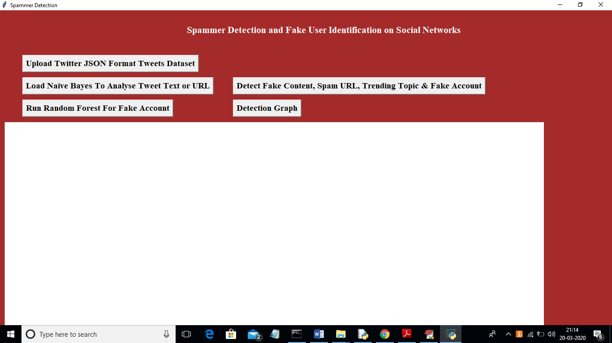

In above screen click on ‘Upload Twitter JSON Format Tweets Dataset’ button and upload tweets folder

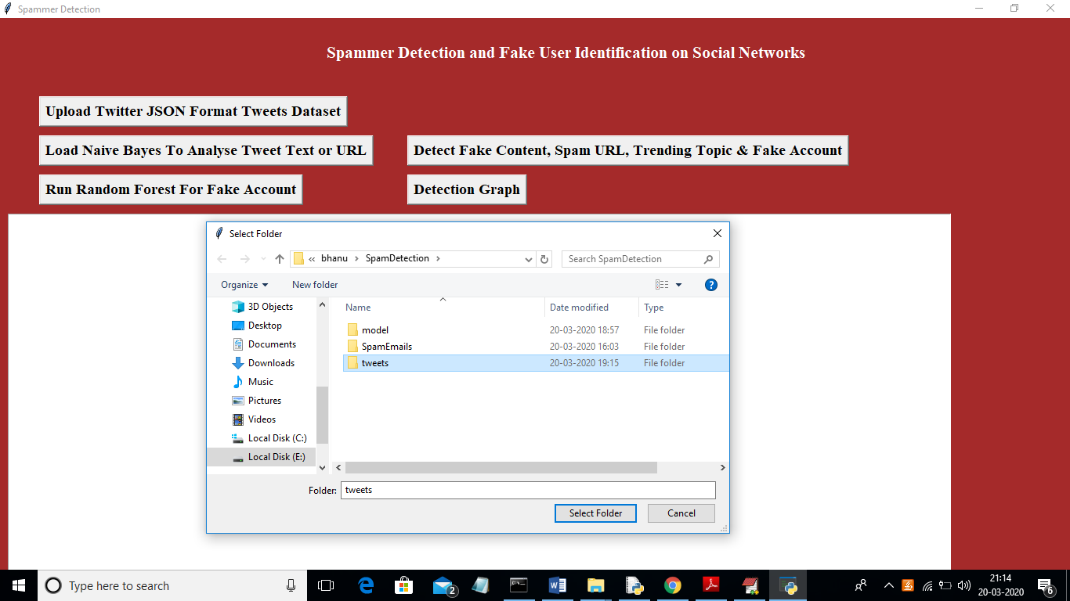

In above screen I am uploading ‘tweets’ folder which contains tweets from various users in JSON format. Now click open button to start reading tweets

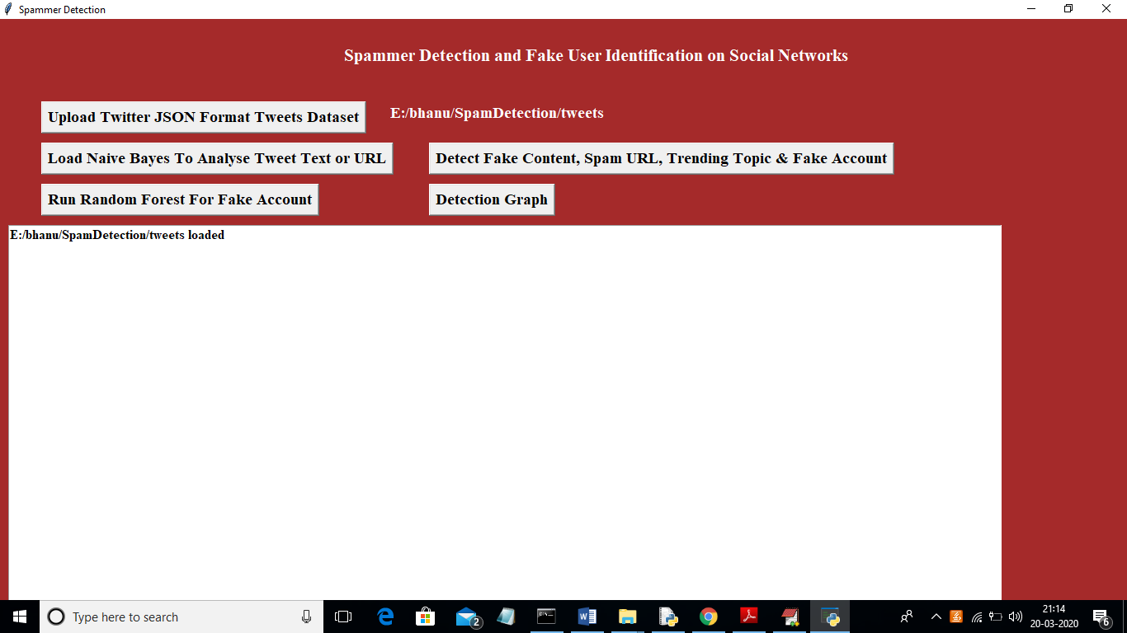

In above screen we can see all tweets from all users loaded. Now click on ‘Load Naive Bayes To Analyse Tweet Text or URL’ button to load Naïve Bayes classifier

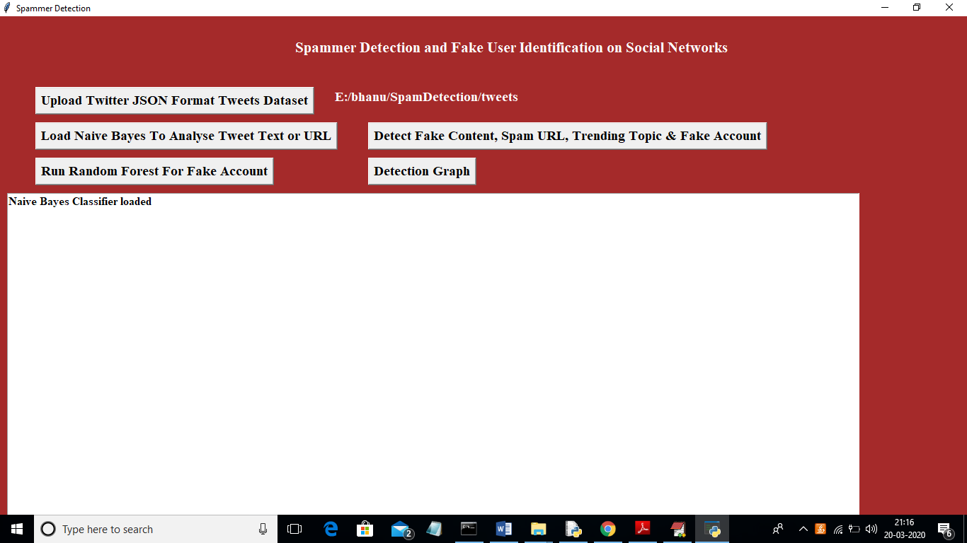

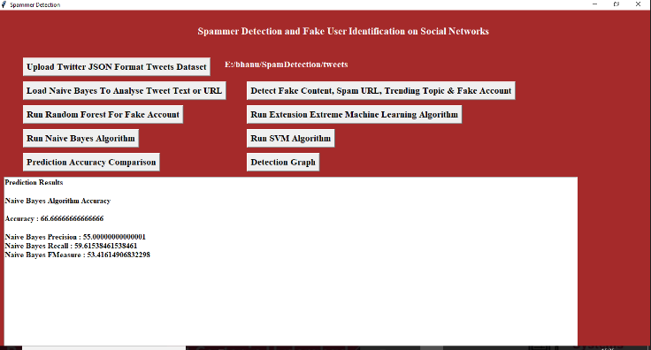
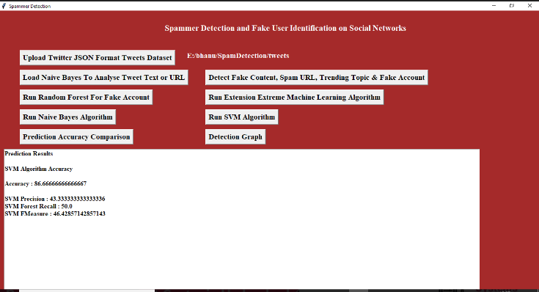

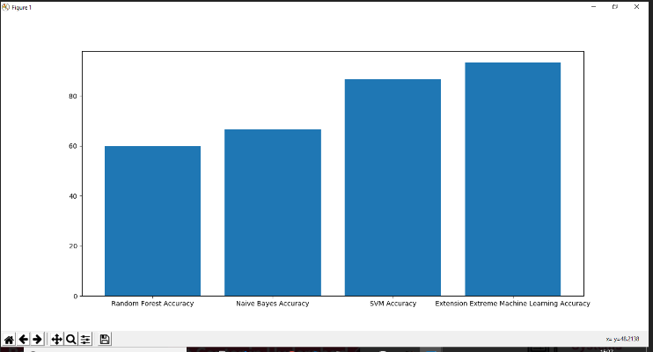

Extension work using EML algorithm
To run project double click on ‘run.bat’ file to get below screen
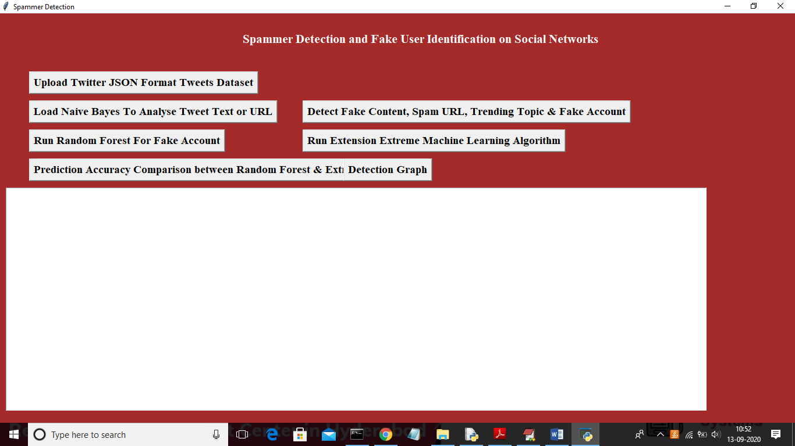

In above screen upload dataset by clicking on ‘Upload Twitter JSON Format Tweets Dataset’ button
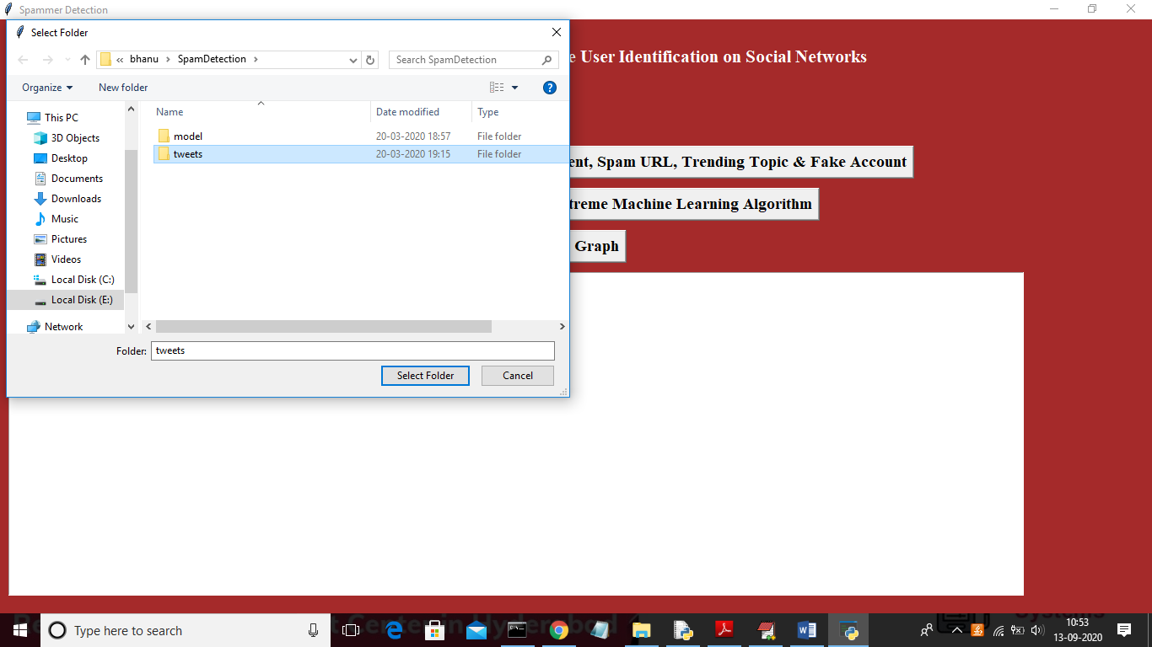
In above screen after selecting tweets folder click on ‘Select Folder’ to load tweets dataset and to get below screen
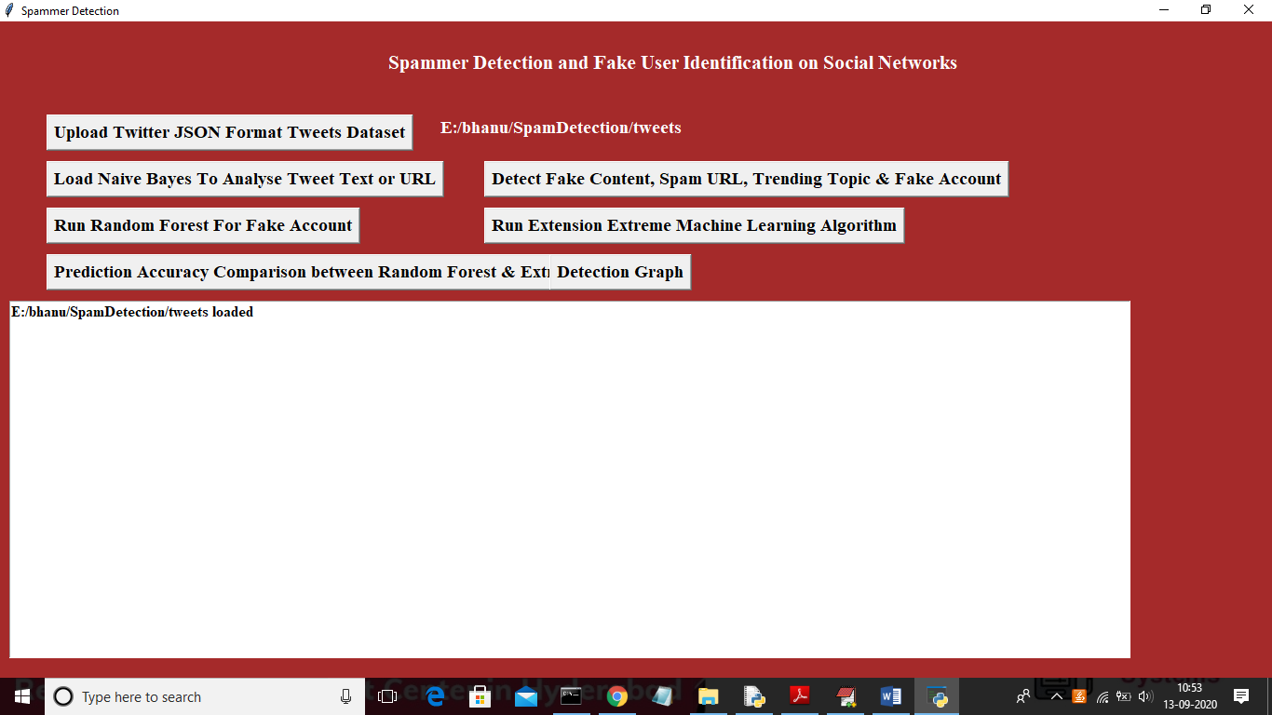

Now click on ‘Load Naïve Bayes To Analyse Tweet Text or URL’ button to analyse tweet text and generate machine learning features

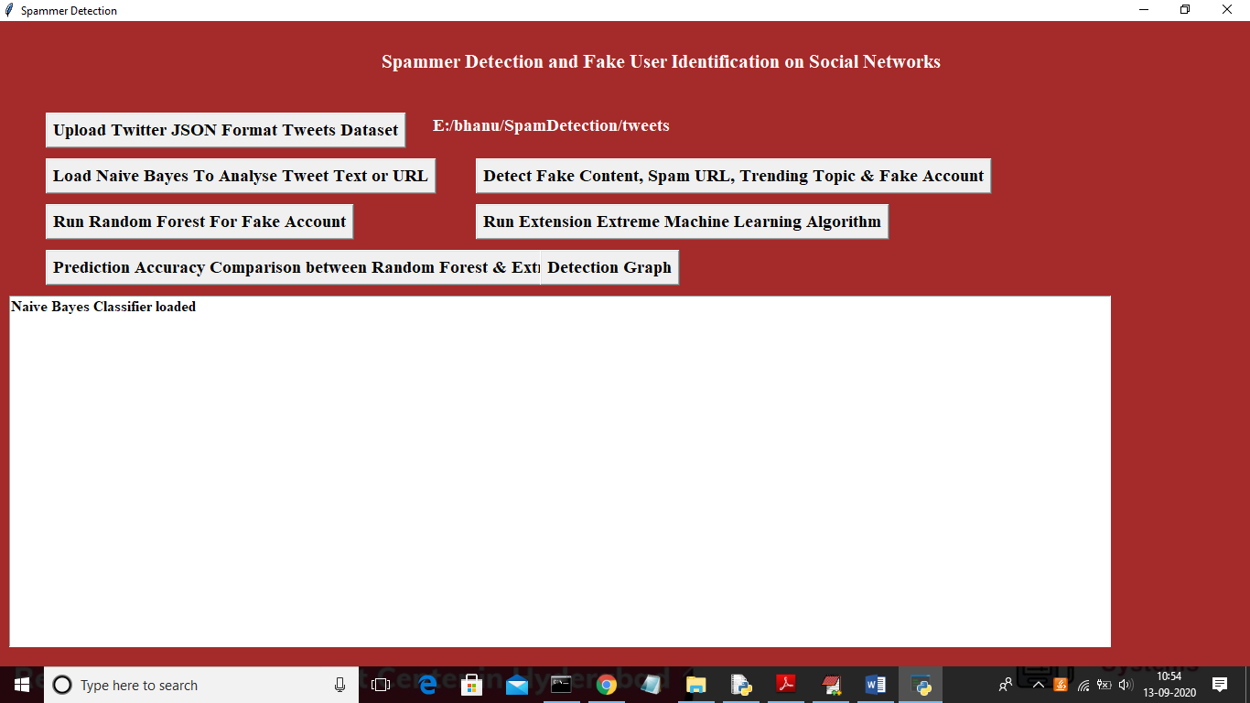
In above screen naïve bayes classifier loaded to analyse tweet text and now click on ‘Detect Fake Content, Spam URL, Trending Topic & Fake Account’ to detect spam accounts and create machine learning features
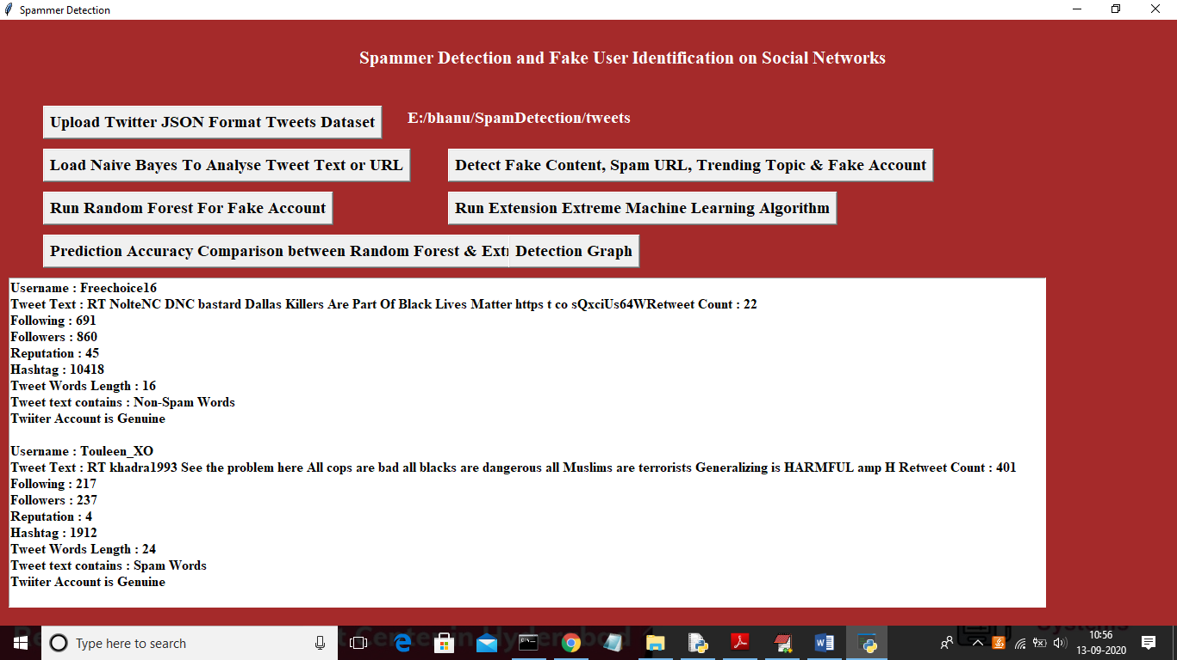
In above screen we analyse all users accounts and then identify whether account is normal or contains spam content using naïve bayes algorithm and now click on ‘Run Random Forest For Fake Account’ button to build machine learning model on above data so in future by applying new account details we can predict whether account is normal or fake.
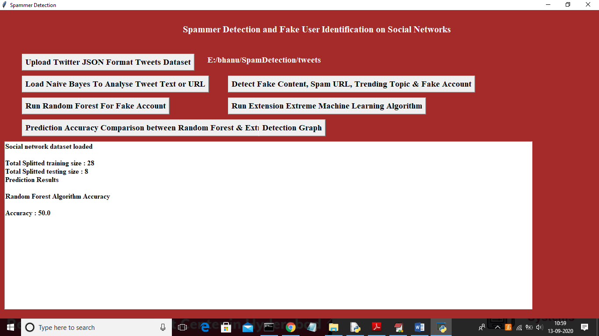
In above screen we can see total dataset contains 36 accounts and application using 80% records (28) for training and 20% records (8) for testing and with random forest we got test data prediction accuracy as 50%. Now click on ‘Run Extension Extreme Machine Learning Algorithm’ button to generate training model on above data and to get prediction accuracy on test data
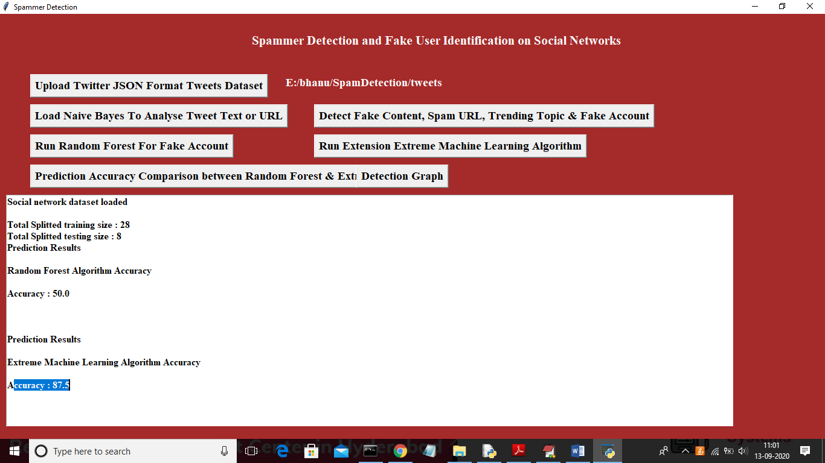
In above screen with extension extreme machine learning algorithm we got 87.5% accuracy and its better in prediction fake or normal account compare to random forest. Here dataset will be splitted to training and testing part randomly so accuracy may vary for each run. Now click on ‘Prediction Accuracy Comparison between Random Forest & Extreme ML’ button to get accuracy comparison between random forest and extreme machine learning
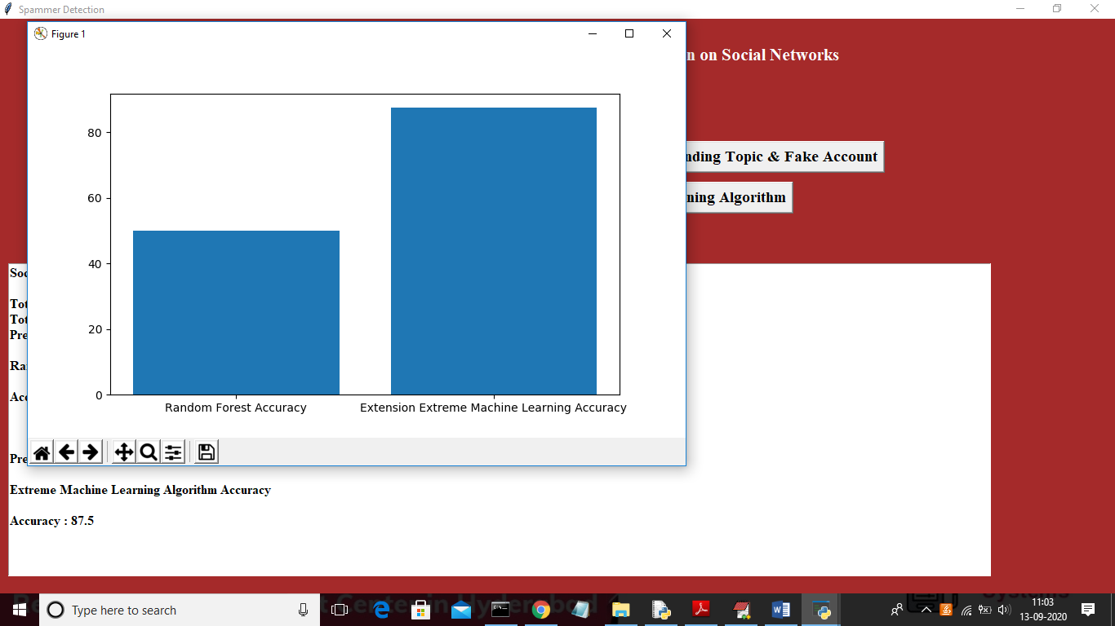

In above graph x-axis represents algorithm names and y-axis represents accuracy of those algorithm and from above graph we can conclude that extension work get better accuracy and now click on ‘Detection Graph’ button to get total accounts, fake and genuine accounts graph
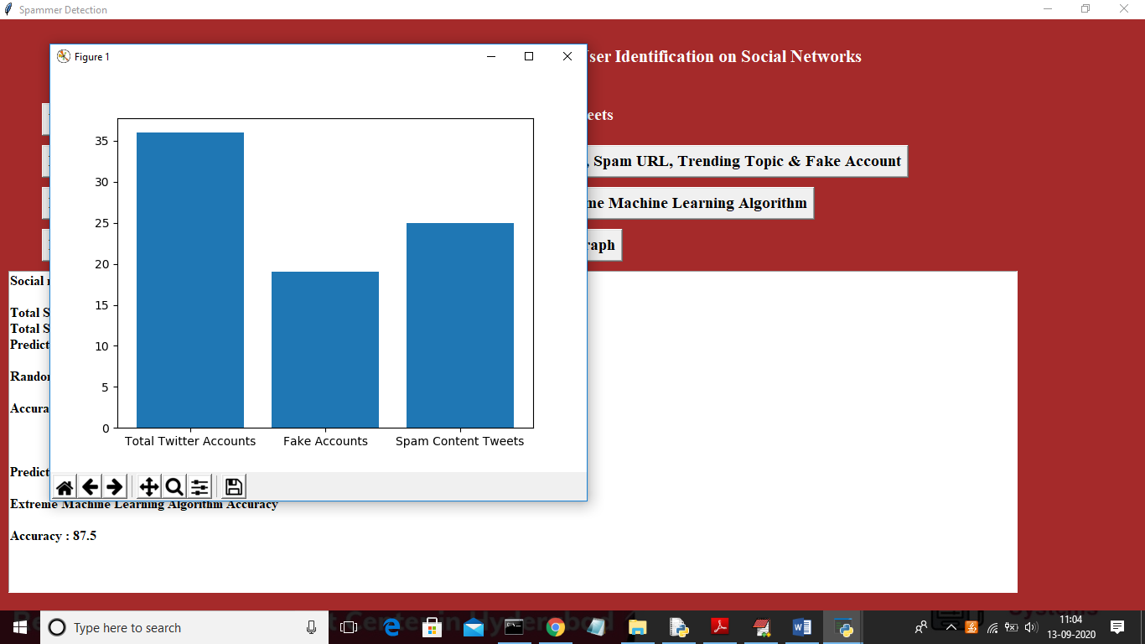
In above graph x-axis represents types of account and y-axis represent count of each type account.

8. CONCLUSION
In this paper, we performed a review of techniques used for detecting spammers on Twitter. In addition, we also presented a taxonomy of Twitter spam detection approaches and categorized them as fake content detection, URL based spam detection, spam detection in trending topics, and fake user detection techniques. We also compared the presented techniques based on several features, such as user features, content features, graph features, structure features, and time features. Moreover, the techniques were also compared in terms of their specified goals and datasets used. It is anticipated that the presented review will help researchers find the information on state-of-the-art Twitter spam detection techniques in a consolidated form. Despite the development of efficient and effective approaches for the spam detection and fake user identification on Twitter [34], there are still certain open areas that require considerable attention by the researchers. The issues are briefly highlighted as under: False news identification on social media networks is an issue that needs to be explored because of the serious repercussions of such news at individual as well as collective level [25]. Another associated topic that is worth investigating is the identification of rumor sources on social media. Although a few studies based on statistical methods have already been conducted to detect the sources of rumors, more sophisticated approaches, e.g., social networkbased approaches, can be applied because of their proven effectiveness.
REFERENCES
[1] B. Erçahin, Ö. Aktaş, D. Kilinç, and C. Akyol, ‘‘Twitter fake account detection,’’ in Proc. Int. Conf. Comput. Sci. Eng. (UBMK), Oct. 2017, pp. 388–392.
[2] F. Benevenuto, G. Magno, T. Rodrigues, and V. Almeida, ‘‘Detecting spammers on Twitter,’’ in Proc. Collaboration, Electron. Messaging, AntiAbuse Spam Conf. (CEAS), vol. 6, Jul. 2010, p. 12.
[3] S. Gharge, and M. Chavan, ‘‘An integrated approach for malicious tweets detection using NLP,’’ in Proc. Int. Conf. Inventive Commun. Comput. Technol. (ICICCT), Mar. 2017, pp. 435–438. [4] T. Wu, S. Wen, Y. Xiang, and W. Zhou, ‘‘Twitter spam detection: Survey of new approaches and comparative study,’’ Comput. Secur., vol. 76, pp. 265–284, Jul. 2018.
[5] S. J. Soman, ‘‘A survey on behaviors exhibited by spammers in popular social media networks,’’ in Proc. Int. Conf. Circuit, Power Comput. Technol. (ICCPCT), Mar. 2016, pp. 1–6.
[6] A. Gupta, H. Lamba, and P. Kumaraguru, ‘‘1.00 per RT #BostonMarathon # prayforboston: Analyzing fake content on Twitter,’’ in Proc. eCrime Researchers Summit (eCRS), 2013, pp. 1–12.
[7] F. Concone, A. De Paola, G. Lo Re, and M. Morana, ‘‘Twitter analysis for real-time malware discovery,’’ in Proc. AEIT Int. Annu. Conf., Sep. 2017, pp. 1–6.
[8] N. Eshraqi, M. Jalali, and M. H. Moattar, ‘‘Detecting spam tweets in Twitter using a data stream clustering algorithm,’’ in Proc. Int. Congr. Technol., Commun. Knowl. (ICTCK), Nov. 2015, pp. 347–351.
[9] C. Chen, Y. Wang, J. Zhang, Y. Xiang, W. Zhou, and G. Min, ‘‘Statistical features-based real-time detection of drifted Twitter spam,’’ IEEE Trans. Inf. Forensics Security, vol. 12, no. 4, pp. 914–925, Apr. 2017.
[10] C. Buntain and J. Golbeck, ‘‘Automatically identifying fake news in popular Twitter threads,’’ in Proc. IEEE Int. Conf. Smart Cloud (SmartCloud), Nov. 2017, pp. 208–215.
[11] C. Chen, J. Zhang, Y. Xie, Y. Xiang, W. Zhou, M. M. Hassan, A. AlElaiwi, and M. Alrubaian, ‘‘A performance evaluation of machine learning-based streaming spam tweets detection,’’ IEEE Trans. Comput. Social Syst., vol. 2, no. 3, pp. 65–76, Sep. 2015.
[12] G. Stafford and L. L. Yu, ‘‘An evaluation of the effect of spam on Twitter trending topics,’’ in Proc. Int. Conf. Social Comput., Sep. 2013, pp. 373–378.
[13] M. Mateen, M. A. Iqbal, M. Aleem, and M. A. Islam, ‘‘A hybrid approach for spam detection for Twitter,’’ in Proc. 14th Int. Bhurban Conf. Appl. Sci. Technol. (IBCAST), Jan. 2017, pp. 466–471.
[14] A. Gupta and R. Kaushal, ‘‘Improving spam detection in online social networks,’’ in Proc. Int. Conf. Cogn. Comput. Inf. Process. (CCIP), Mar. 2015, pp. 1–6.
[15] F. Fathaliani and M. Bouguessa, ‘‘A model-based approach for identifying spammers in social networks,’’ in Proc. IEEE Int. Conf. Data Sci. Adv. Anal. (DSAA), Oct. 2015, pp. 1–9.
[16] V. Chauhan, A. Pilaniya, V. Middha, A. Gupta, U. Bana, B. R. Prasad, and S. Agarwal, ‘‘Anomalous behavior detection in social networking,’’ in Proc. 8th Int. Conf. Comput., Commun. Netw. Technol. (ICCCNT), Jul. 2017, pp. 1–5.
[17] S. Jeong, G. Noh, H. Oh, and C.-K. Kim, ‘‘Follow spam detection based on cascaded social information,’’ Inf. Sci., vol. 369, pp. 481–499, Nov. 2016.
[18] M. Washha, A. Qaroush, and F. Sedes, ‘‘Leveraging time for spammers detection on Twitter,’’ in Proc. 8th Int. Conf. Manage. Digit. EcoSyst., Nov. 2016, pp. 109–116.

